Web based SpringBoot ,React Project-Product Management App

Testing Restful API POST Request with Postman

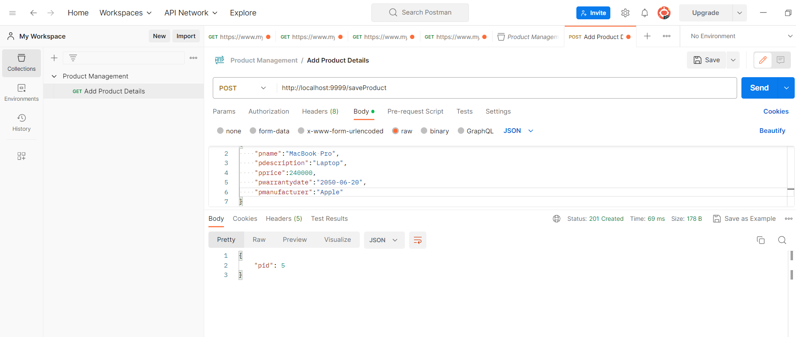

React UI

Create Components

Install React Router dom for navigation

npm i react-router-dom@6.0.2